Jagjot Singh

Dr. Nilesh Patel

CSI4999

1/23/2020

**LogBook Entry For Sprint 1**

I wasn’t sure how you wanted the proof for the work but I did two all nighters and drank a lot of coffee. Heres what I did, and can you provide feedback so I know what I can do for next logbook thanks in advance!

1. Developed backend server on google cloud

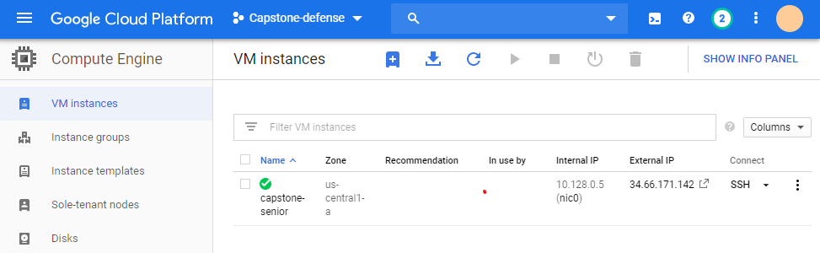

Setup the server in Ubuntu LTS 16, and created a LAMP server or (linux, apache2, mysql, and php). This virtual machine instance is being used to host the website at the moment. **Effort hours: ~3-4 hours** → mostly because issues arise with setting permissions for mysql reading.

1. Created tables in mySQL and ERD diagrams *UPDATE* status was added to table

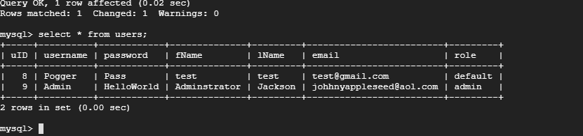

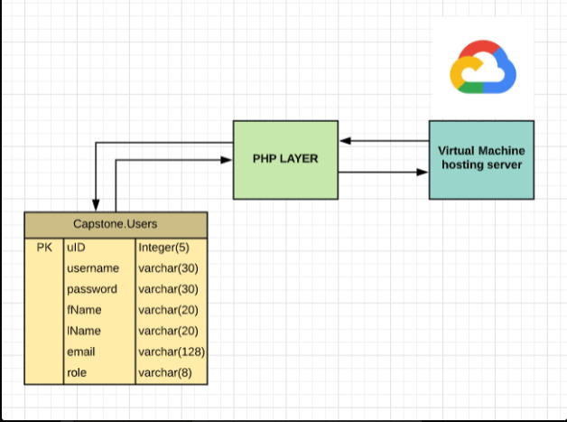

1. Created front end design for website: **All front end code can be viewed in website folder for master. Effort Hours: ~4-5 hours *number varies refer uptop**

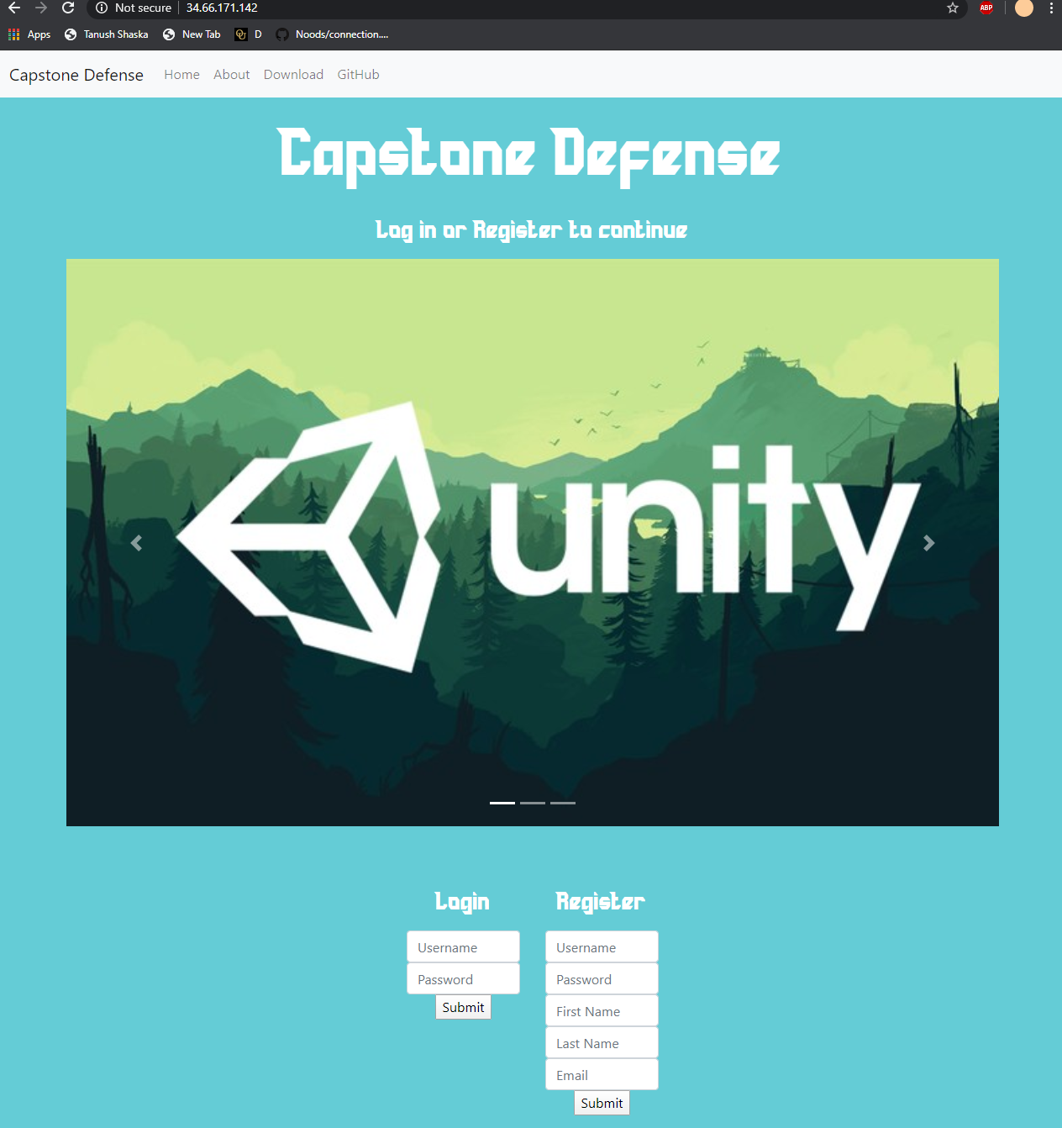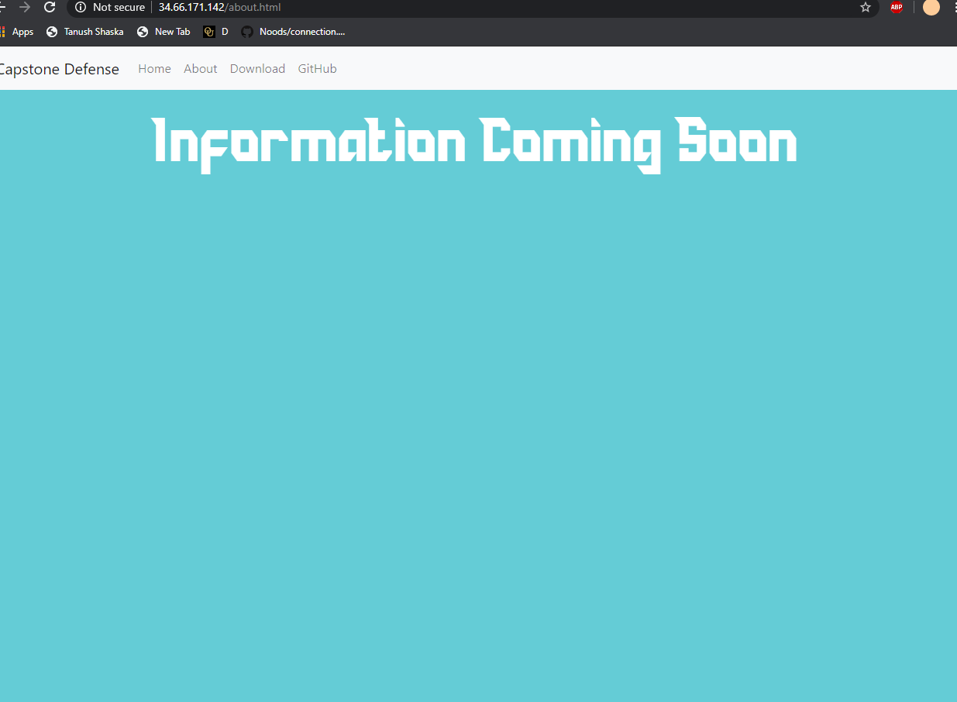

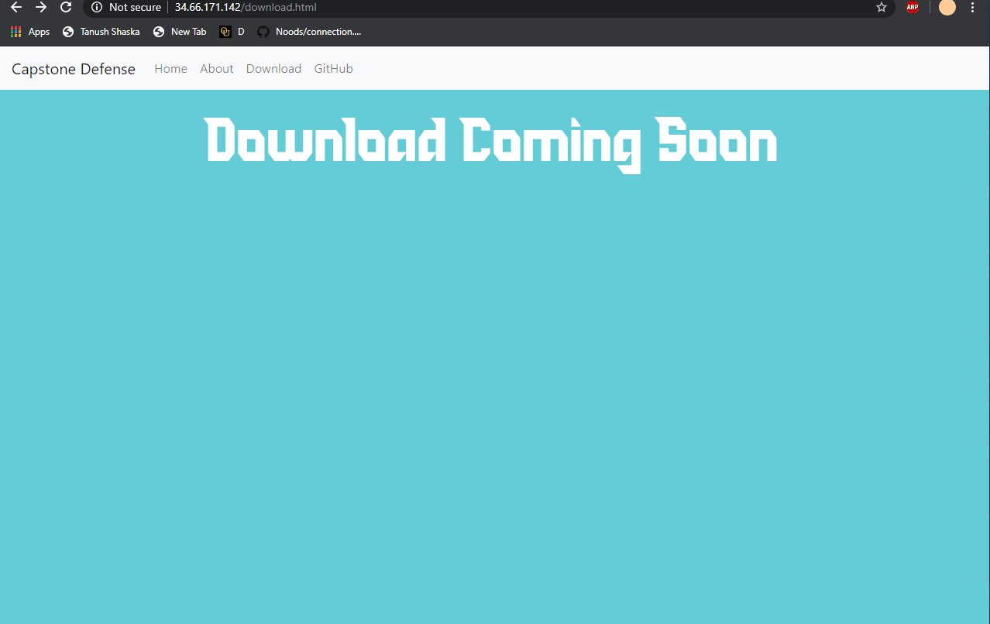

1. Backend connections to sql server and php made so users can register and input **~2-3 hours**
2. Setting up email server to send out emails: **Effort Hours ~3 hours**

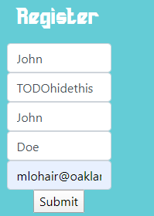



1. Creating code to handle security, behavior of inputs, and clean up of front end/backend

**~5-6 hours**

These include:

**Carosoul view**

**Different php files**

**Email server clean up**

**Registration fix for incorrect inputs**

**….**

**Alot more but I didn’t log everything**

1. Worked on presentation **~1 hour**

**Sprint 2 Documentation**

*Details:* This sprint was used as a way to tidy up backend, and add features to the website. This also included fixing up the backend logic and incorporating demo developed by team onto website. Refer below to all the work done…ALL COMMITS AND WORK ARE SEEN ON GITHUB UNDER <https://github.com/JTBridges/Capstone-Defence> and specific commits

<https://github.com/JTBridges/Capstone-Defence/commits?author=jagjotsingh1>

1. Clean up pages and fix navbar issues **~2 hours**

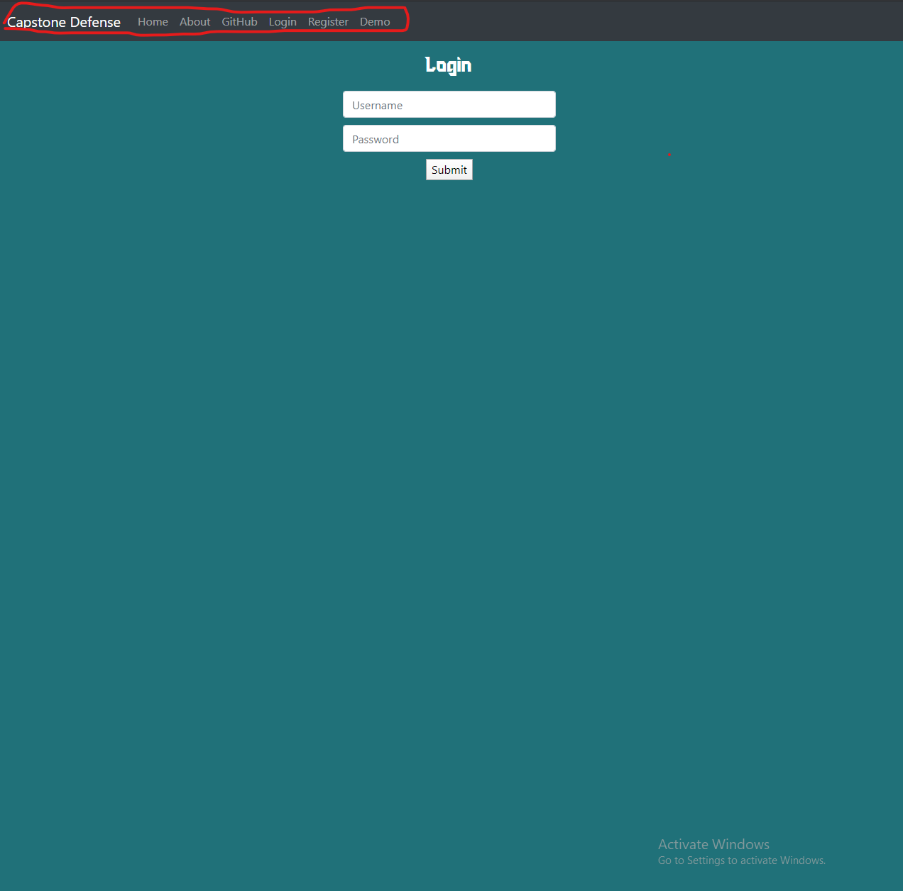

This included separating login page, register, demo, and everything else to tidy up backend for server

1. Work on update profile page, link backend, and working on sessions php ~**5 hours**

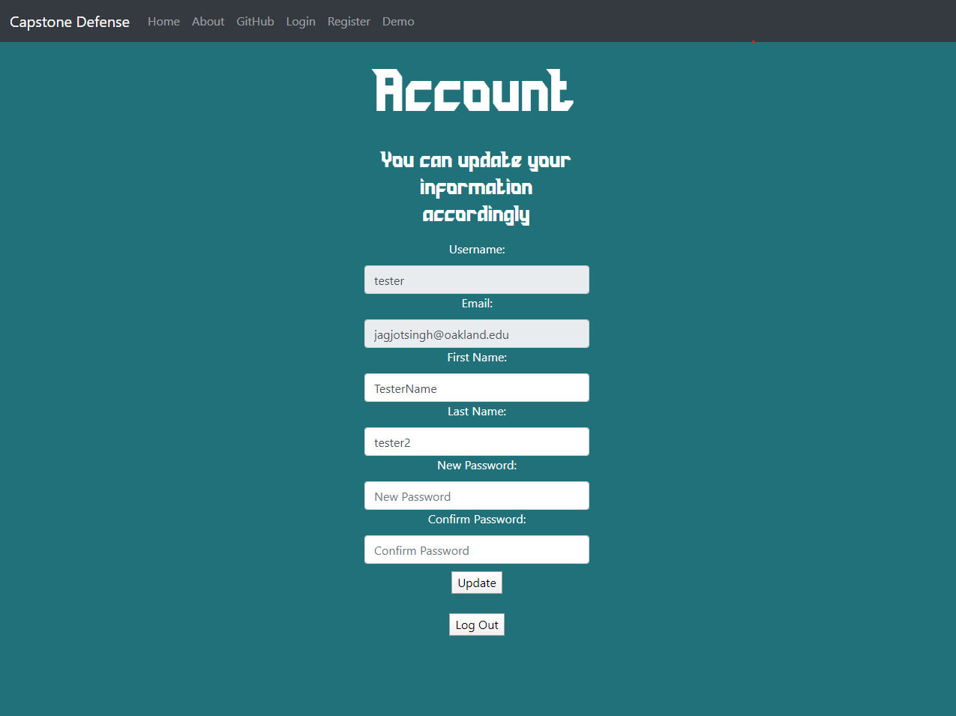

Included setting up all the formatting, and the majority of the time came into incorporating sessions to hold global variables to search with. The front end looks a bit bad, but that can be fixed with an overhaul on UI design for the website sprint 3.

1. Updated table backend and got email verification with link working. **~4 hours**

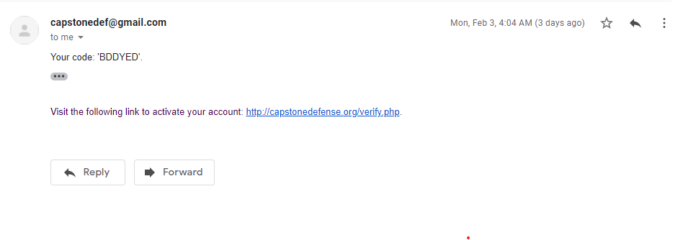

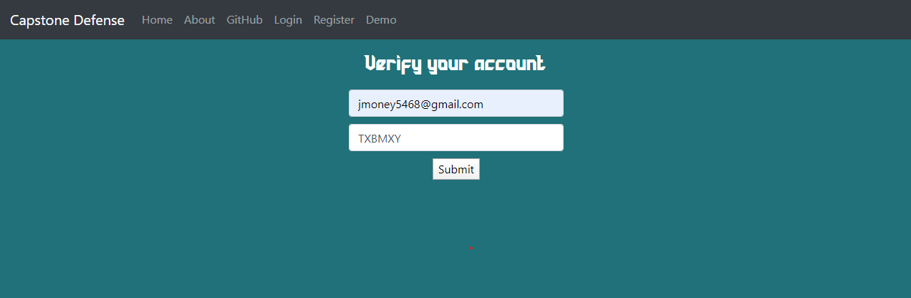

The hash is generated and sent via the mail exchange server to target email. The email also includes a verification page to unlock accounts to post scores.

1. Created landing pages and also incorporated logic on inputs fe)required forms, valid email, etc. **~6 hours**

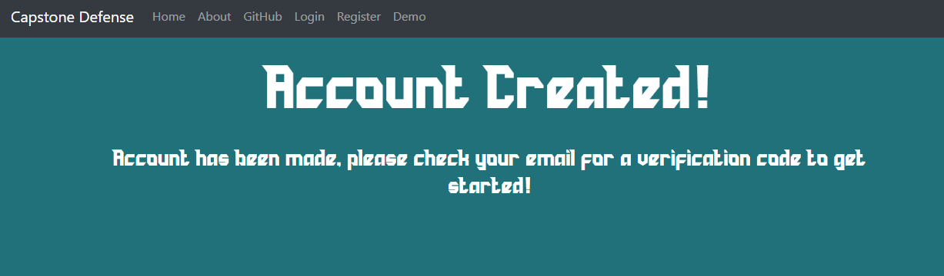

Landing pages didn’t take too long but the logic and what security we need took a long time. As its hard to demonstrate that looks, the backend is processing inputs on what the user submits in forms and checks if they are valid responses. This took a very long time.

1. Presentation, documentation, and extra information **~1 hour**

This part includes adding to slides, and also documentation/commenting the code so other people can view. I also created a guide on how to connect to the server using filezilla; however, have not made this public because of security concerns for our server. We essentially are using a ppk file to connect in using FILEZILLA SFTP.